

**Monday 28**

**Tuesday 29**

**Wednesday 30**

**Thursday 1**

**Friday 2**

Guest Teacher

SCANTRON Testing

SCANTRON Testing

SCANTRON Testing

**Email Address:** [**mschafer@pacek-8.org**](mailto:mschafer@pacek-8.org)

**Phone Contact:** (248) 569-1060 ext 2204

**Website:**  <http://pace5thgrade.weebly.com/>

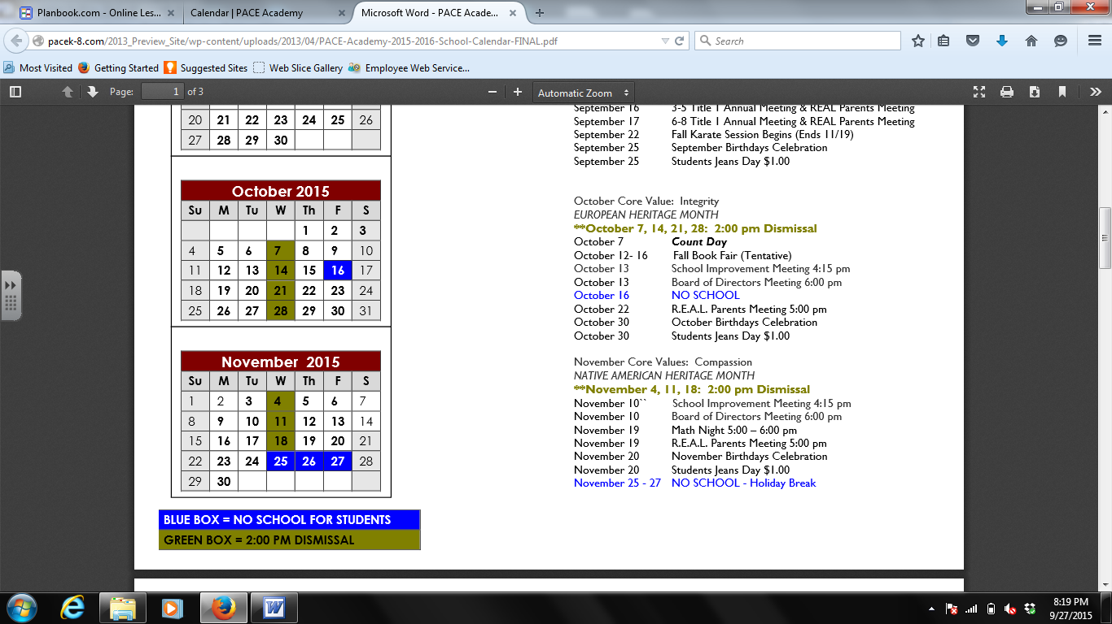

**Science-**

Speed: Students will be able to measure velocity of different objects.

**Math-**

**MON**- 1.6 Place Value

**TUES-** Place Value Quiz

**WED-**  Math Stations

**THUR-**  1.7 Compare Decimals

**FRI-** 1.8 Order whole numbers & Decimals



Cameron Starks

**7:45-8:00 Breakfast**

**8:00-8:45 Social Studies**

**8:50-9:35 Science (Ms. Nezich)**

**9:40-10:20 1st Special**

**10:25-12:00 Reading**

**12:05-12:35 Lunch**

**12:40-12:55 Recess**

**1:00-1:40 Writing**

**1:45-2:40 Math (Ms. Nezich)**

**2:45-3:25 2nd Special**

**3:25-3:40 DEAR time**

**3:45 Dismissal from classroom**

**Focus Skill:** Main Idea

Ebli is going great! Please ask your child how to stay and write the word aberration.

**Spelling:** Spelling Words will come home on Monday.

**Writing:** Personal Narrative

Continent test has been graded and passed back. Please ask your child how he/she did.

**New Unit: Native Americans**

Students will learn and understand about the major regions: Eastern Woodlands, Pacific Northwest, Great Plains, and the Desert Southwest.