

**Monday 21**

**Tuesday 22**

**Wednesday 23**

**Thursday 24**

**Friday 25**

Spelling & Reading Tests passed back.

New Words Sent home

Theme Post Test

Continents & Oceans Test

**Email Address:** [**mschafer@pacek-8.org**](mailto:mschafer@pacek-8.org)

**Phone Contact:** (248) 569-1060 ext 2204

**Website:**  <http://pace5thgrade.weebly.com/>

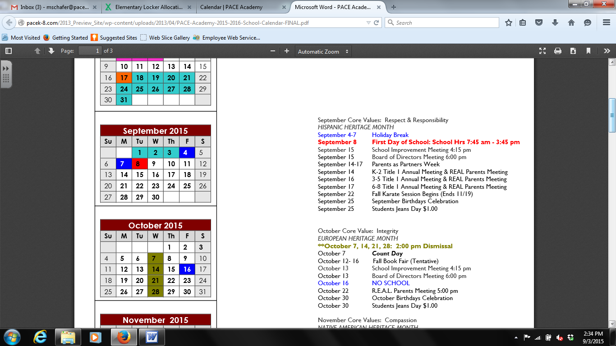

**Science:** Changing Directions

Force

QUIZ: Thursday 9-24

**Math:** L1.3 Model Fractions & Decimals

L1.4 Represent Decimals

L1.5 Understand Place Value



Ta’Ja

Cooper

Geography Review

TEST: Thursday, Sept 24th

Students will need to know the names and location of the 7 continents and 5 oceans, as well as; the cardinal directions.

**7:45-8:00 Breakfast**

**8:00-8:45 Social Studies**

**8:50-9:35 Science (Ms. Nezich)**

**9:40-10:20 1st Special**

**10:25-12:00 Reading**

**12:05-12:35 Lunch**

**12:40-12:55 Recess**

**1:00-1:40 Writing**

**1:45-2:40 Math (Ms. Nezich)**

**2:45-3:25 2nd Special**

**3:25-3:40 DEAR time**

**3:45 Dismissal from classroom**

**Focus Skill:** Theme

Ebli will start this week!

**Spelling:** Spelling Words will come home on Monday.

**Writing:** Compare/Contrast