

**Monday 14**

**Tuesday 15**

**Wednesday 16**

**Thursday 17**

**Friday 18**

Planners & Reading Logs go Home Today

Reading Quiz & Spelling Test

Guest Teacher

**Email Address:** [**mschafer@pacek-8.org**](mailto:mschafer@pacek-8.org)

**Phone Contact:** (248) 569-1060 ext 2204

**Website:**  <http://pace5thgrade.weebly.com/>

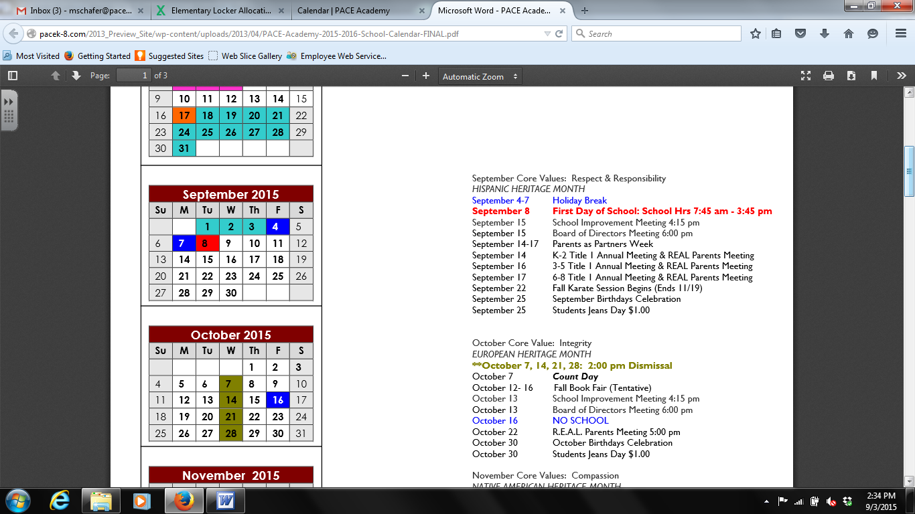

Our students will start switching classes this week. Students will transition to Ms. Nezich in the morning for science and in the afternoon for math. Please visit our team’s website for more information on the math and science curriculum for this week.

Mrs. Schafer



Geography Review

TEST: Mon, Sept 21st

Students will need to know the names and location of the 7 continents and 5 oceans.

**7:45-8:00 Breakfast**

**8:00-8:45 Social Studies**

**8:50-9:35 Science (Ms. Nezich)**

**9:40-10:20 1st Special**

**10:25-12:00 Reading**

**12:05-12:35 Lunch**

**12:40-12:55 Recess**

**1:00-1:40 Writing**

**1:45-2:40 Math**

**2:45-3:25 2nd Special**

**3:25-3:40 DEAR time**

**3:45 Dismissal from classroom**

**Storytown:** Lesson 1 Rope Burn

**QUIZ:** Friday, Sept 18th

Ebli will start this week!

**Spelling:** Spelling Words will come home on Monday.

**Writing:** Compare/Contrast