

**Monday 7**

**Tuesday 8**

**Wednesday 9**

**Thursday 10**

**Friday 11**

Full Day of school for all K-8 Students

First Day

of School for 5th Grade

**Email Address:** [**mschafer@pacek-8.org**](mailto:mschafer@pacek-8.org)

**Phone Contact:** (248) 569-1060 ext 2204

**Website:**  <http://pace5thgrade.weebly.com/>

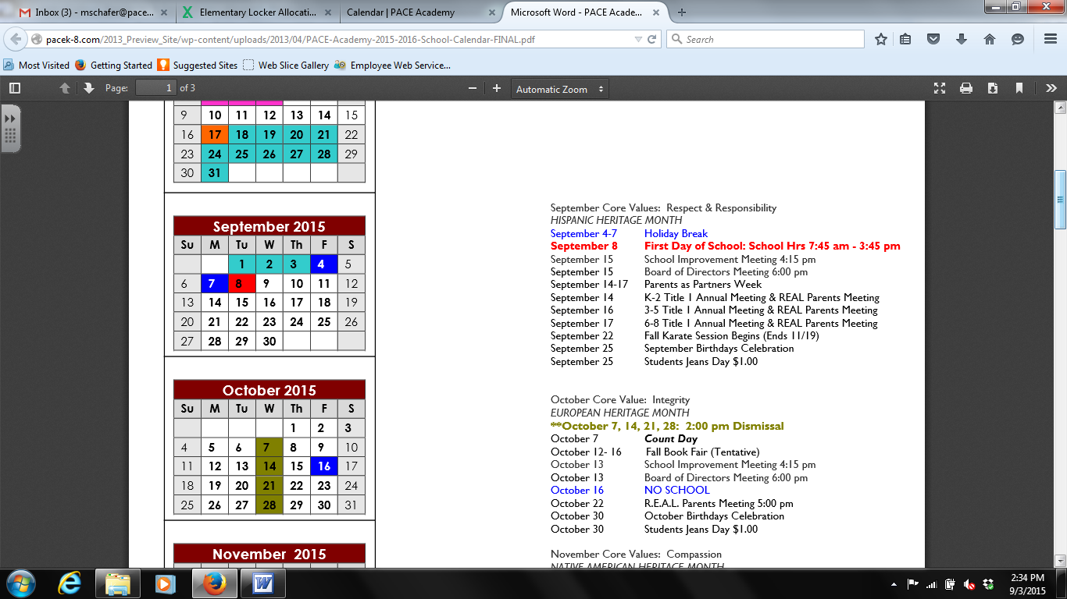

Ms. Nezich will be teaching the class Math and Science throughout this year. Classes will switch daily. Students will be responsible for keeping track of assignments, tests, and homework that are assigned.



Mrs. Schafer



I will be teaching the class reading, writing, and social studies this year. Students will have spelling and vocabulary tests, and bi-weekly reading tests. Social studies will be taught daily.

**7:45-8:00 Breakfast**

**8:00-8:45 Social Studies**

**8:50-9:35 Science (Ms. Nezich)**

**9:40-10:20 1st Special**

**10:25-12:00 Reading**

**12:05-12:35 Lunch**

**12:40-12:55 Recess**

**1:00-1:40 Writing**

**1:45-2:40 Math**

**2:45-3:25 2nd Special**

**3:25-3:40 DEAR time**

**3:45 Dismissal from classroom**

**Your child will be bringing home a homework folder, planner, and reading log each day. Please check with your child that they’ve completed their homework, received any signatures needed and are prepared for school each day.**

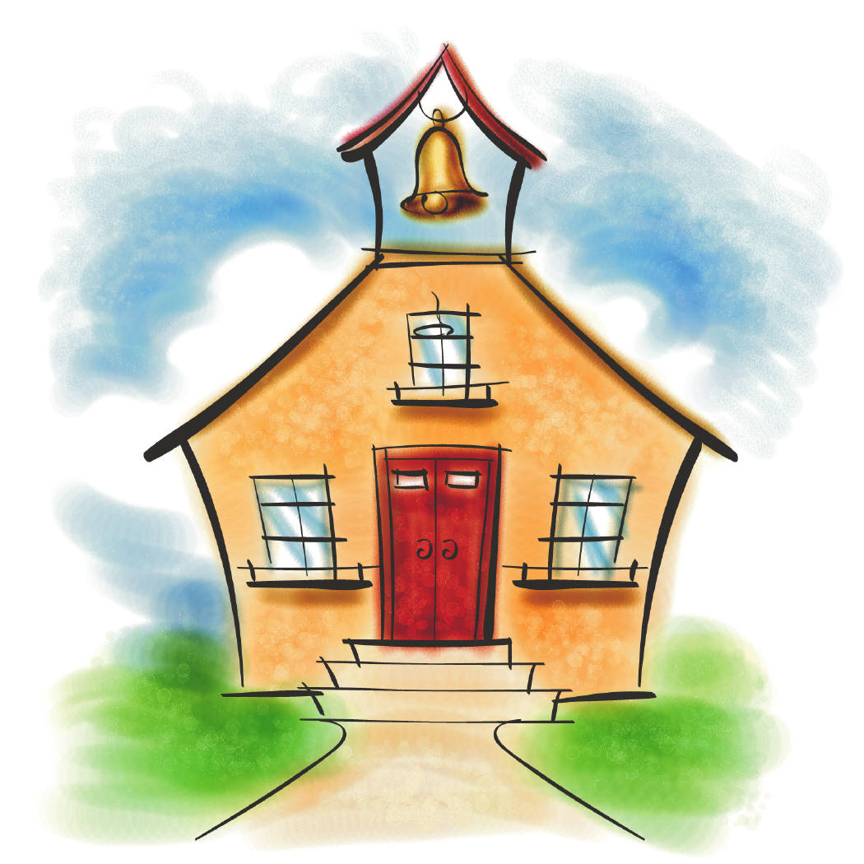

**Important Information**

**Reading Logs/ Planners**: Students will receive a planner for our class and record homework and behavior on it daily. **Reading Logs**: Every night the students must read at least 20 minutes everyday independently. An adult must sign their reading log each night.

**PowerSchool**: PowerSchool will be updated frequently. Please make sure to check on your students grades. Also, sign up for text alerts about student’s grades.

**Grading Scale**:

1. Class Assignments – 30%
2. Quizzes – 15%
3. Tests – 30%
4. Homework – 10%
5. Projects – 10%
6. Participation – 5%

**Classroom Newsletter/Website:** A classroom newsletter will be sent home every Monday. Also, please check our website for spelling and vocabulary words. Email & website are on each newsletter.

**Birthday Celebrations**: PACE participates in a healthy school initiative, which only allows for one birthday celebration per month. Our monthly birthday celebrations will be on the last FRIDAY of the month. A good alternative to bringing cupcakes on the actual day of your child’s birthday is to bring stickers, pencils, eraser tops, etc that your child can pass out to the class.

**Early Release Wednesdays**: This year students will be getting out at 2:00 PM every Wednesday. This will begin October 14th.

**Dismissal**: We will dismiss from the classroom at 3:45. Early dismissal ends at 3:00, parents needing an early dismissal need to go to the office, they will call the classroom to send you student down. Please keep in mind that two early dismissals equal an absence; after 20 absences students may be dismissed from PACE. See the handbook for the full policy.

**Arrival:** Students that arrive before 7:45 AM are asked to meet in the cafeteria until I pick them up in the morning.

**Tardy:** Anyone arriving after 8:10 AM will be marked Tardy.

(2 Tardy = 1 Absence)

**Breakfast & Lunch**: Students are provided free breakfast and lunch each day. Breakfast will end promptly at 8:00. Students who arrive late will miss breakfast; please do your best to have your child arrive on time to ensure he/she may enjoy breakfast each morning.

**No Food Share Policy**: In an effort to be amore health and safety conscience school, students will not be aloud to share any food with other students.

**Do Now:** Every morning when the students enter the classroom, they will have a Do Now assignment. Those should be completed first thing in the morning.

**Medication**: If your child requires medication throughout the day it must be stored in and distributed by the office, and the correct paperwork must be filled out. Please see the school secretary for additional information. No medication will be stored or distributed in our classroom.

**Dress Code:** The school dress code requires 5th Grade to wear a black polo-style shirt and khaki or black bottoms. Students may wear shorts and skirts but they must be at least fingertip length.

Our room tends to be quite chilly, a cardigan is recommended to be kept in your child’s locker. Dress code requires cardigans and sweaters to be burgundy or black. Students that are out of dress code will be required to call home for new clothes. Please refer to handbook for more information.

**Silent Hallway Policy:** When students are in the hallway for any reason there should be NO talking. Students in other classrooms are working, and they should no disturb anyone. Also, when students are walking in the halls, they should stay on the right side of the hallway.