

**Monday 5**

**Tuesday 6**

**Wednesday 7**

**Thursday 8**

**Friday 9**

PICTURE DAY!!!

&

Count Day

Reading Test

Spelling Test

Social Studies Test

**Email Address:** [**mschafer@pacek-8.org**](mailto:mschafer@pacek-8.org)

**Phone Contact:** (248) 569-1060 ext 2204

**Website:**  <http://pace5thgrade.weebly.com/>

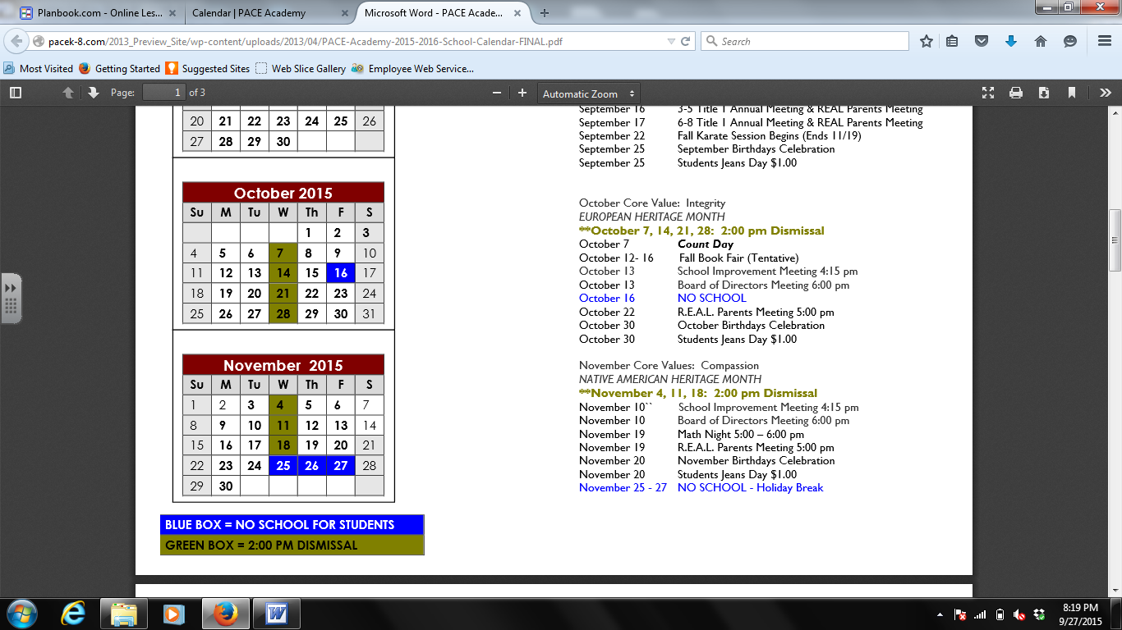

**Science-**

**MATH**

**Mon**-

**Tues-**

**Wed-**  Math Stations

**Thur-**

**Fri-**



Aaliyah Fountain

**7:45-8:00 Breakfast**

**8:00-8:45 Social Studies**

**8:50-9:35 Science (Ms. Nezich)**

**9:40-10:20 1st Special**

**10:25-12:00 Reading**

**12:05-12:35 Lunch**

**12:40-12:55 Recess**

**1:00-1:40 Writing**

**1:45-2:40 Math (Ms. Nezich)**

**2:45-3:25 2nd Special**

**3:25-3:40 DEAR time**

**3:45 Dismissal from classroom**

**Focus Skill:** Main Idea

Ebli is going great! Please ask your child to show you a word with the <ea> sound.

**Spelling:** Spelling Words will come home on Monday.

**Writing:** Personal Narrative

Thinking Like a Historian

Students will be learning hoe a historian thinks by analyzing different sources, asking questions, and understanding cause and effect.

TEST: Friday, October 9th.